title of the paper (UCJ_Titul)
Name and surname of the author – name and surname of co-author (UCJ_autor)
Abstract
Abstract in the English language, no more than 200 words.
Keywords: write the keywords in lower case letters, use commas, no full stop at the end (UCJ_abstrakt)
Introduction (UCJ_kapitola)
Paper written in English, up to 10 pages including Abstract, Keywords and References. (UCJ_normalny-text)
1 chapter
This Word document is a template for writing the original paper meant for the conference “Artificial Intelligence – a Revolution in Foreign Language Teaching? Language Education in the Digital Age”. The document provides the authors with graphic layout, formatting, and styles. Please, send the used pictures and tables also in individual files: surname_fig1.jpeg, surname_fig2.jpeg, surname_tab1.xlsx, surname_tab2.xlsx etc.
2 chapter
All the styles and formatting required for the paper are set in this document. Used styles are easily recognizable – they have the first three letters UCJ_ and are mentioned in brackets in respective parts. Use these styles or just replace the text in this template document with your text.
2.1 Sub-chapter (UCJ_Podkapitola)
The required paper size is A4. The maximum length of the paper is 10 pages, including References.
2.2 Text
The margins in the document are set to 2.5 cm on all sides. Use 1.5 line spacing in your paper.
Do not number the pages. The numbering will be set by the technical editor of the proceedings.
2.3 Styles and formatting
Use the Times New Roman font throughout the document, the font size is preset in individual styles.
2.4 Formatting citations in the text and other requirements
All references in the text must be marked in compliance with the standards, i. e. the source of information must be put in brackets: (Surname of the author, year, page).
Bind the indefinite article with the next word using a fixed space (they do not remain alone at the end of the line). To insert a fixed space between the article and a word, press Ctrl+Shift+Spacebar.
Centre your figures in the middle of the page and describe them below. The style for captioning figures is also preset in the styles of this document (UCJ_obrázky). Please, send the figures used in the text also in individual files: surname_fig1.jpeg, surname_fig2.jpeg etc.
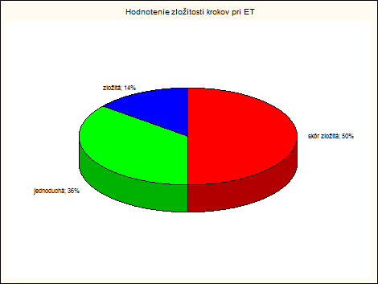
Figure 1 Assessment of the complexity of ET steps
Describe the tables above them in the style specified for labelling tables (UCJ_tabuľky). Use font size 10 for tables (UCJ_text_tabulky).
Tab 1 Average time to achieve temperature at the adhesive joint
Glue line | τ110 (s) | τ120 (s) | Δτ (s)
GL1 | 129.6±11.6 | 90.2±4.1 | 39.4
GL2 | 141.8±12.5 | 111.1±4.4 | 30.7
GL3 | 143.0±11.6 | 119.3±6.5 | 23.7
CONCLUSION
Send the complete paper by 30 June 2025 to the conference email address: ucjtuzvokonferencia@gmail.com. Save the paper in Word text editor format. Name the file: surname_name.doc.
REFERENCES
KOLEČÁNI LENČOVÁ, Ivica – ĽUPTÁK, Marek 2021. Plurilingual approach in foreign language teaching and foreign language teacher education in Slovakia from the interdisciplinary point of view. In AD ALTA : Journal of Interdisciplinary Research. 2021, Vol. 11, No. 1, pp. 176–180. ISSN 1804-7890. http://dx.doi.org/10.33543/1101
GODE, Alexander. 1994. Interlingua. Krupina : Nikara, 124 pp. ISBN 80-8046-020-5.
TOMIN, Július. 1995. Interlingua. In Mistrík, J. et al. Jazyková encyklopédia. Bratislava : Filozofická fakulta Univerzity Komenského, 1995, Vol. 2, pp. 81–84.
TIMKO, Andrej. 2020. Lingvo-kultúrny kontakt a vzájomná interakcia medzi angličtinou a francúzštinou – historický náhľad : Linguo-cultural contact and mutual interaction between English and French – historical insight. In Veverková, Darina – Ľupták, Marek et al. (eds.) Aplikované jazyky v univerzitnom kontexte VII : Recenzovaný zborník vedeckých prác. Zvolen : Technická univerzita vo Zvolene, 2020, pp. 339–355. ISBN 978-80-228-3233-5. [2021-02-11]. Available online: https://ucj.tuzvo.sk/sites/default/files/aplikovane_jazyky_v_univerzitnom_kontexte_vii.pdf

(UCJ_literatura-zoznam)

